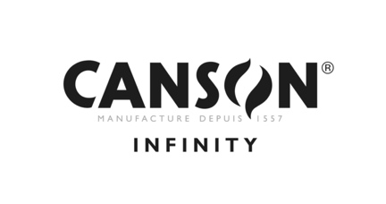
Canson Infinity Baryta Prestige II

Weight (gsm) | 340
Thickness (µm) | 400
Surface feel | Smooth
Surface finish | Gloss
Composition | Alpha-cellulose and cotton
CIE Whiteness | 88
Acid free paper | Yes
OBA content | No
Drying time | Immediate
Water resistance | High
ISO 2471 Opacity | >99
Internally buffered | Yes
Additional comments | Optimised for Pigment and Dye Inks  ISO 9706  FSC Certified

